Short manual

Hopefully you will enjoy this computer. Because this computer might work a bit different from what you may be used to, you will find some important tips in this manual.

Startup
The batteries of this computer are not in good state. Please connect the computer to the power cord and wait for 1 minute before you start the computer.

A common problem is that you might be getting an error while starting the computer regarding the battery or CMOS. In all cases, a weak battery is the source. You can always proceed with booting the computer as these errors are harmless.

However, as a result of getting the error the time and date might be incorrect after boot. The computer will usually correct the date and time within 5 minutes when there is an internet connection avaible. Until the time and date have been corrected, many programs and website will refuse to work properly.

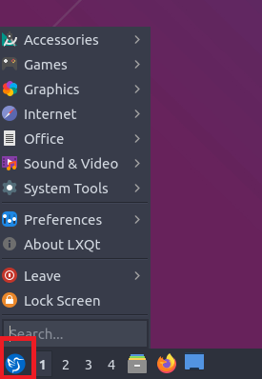
General
For starters, the computer will ask for a username and password every now and then. For this computer the password is Welkom.123!

You can start programs using the ‘start’ button which is located on the bottom left of the screen. See the image to the right.

Change password
It is strongly recommended to change your password at first use of the computer. You can proceed like this:
- Click the ‘start’ button (see image above)
- Go to Preferences
- Go to LXQt settings
- Go to User and groups
- Click on ‘gebruiker’ and then ‘change password’

Change language
You can change the language like this:
- Click the ‘start’ button (see image above)
- Go to Preferences (or ‘instellingen’ in Dutch)
- Go to LXQt settings
- Go to User and groups
- Go to locale
- Choose the right language (for instance United States – American English)

WiFi
In case you received a laptop, you can cannot to WiFi with the WiFi button at the lower right corner of the screen.

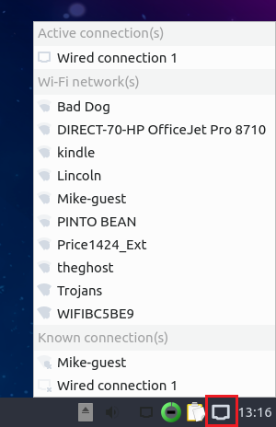
A tip: if connecting continues to fail, then right click the WiFi button and choose ‘edit connections’. Note: the icon might change to 3 bars like depicted below.
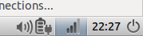

You should then see a list with connections. Click your connection and then the gear icon. This will allow you to see the password you entered. You might have made a mistake while typing the password. See the example below:
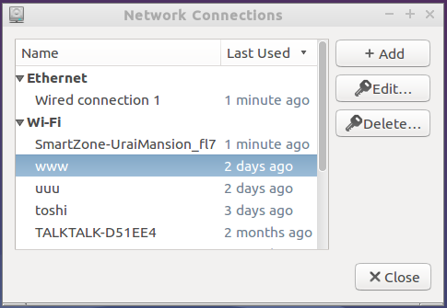

Software
You can find the following software on this computer:
- Firefox, Chrome and Edge for browsing the internet
- Thunderbird for email and calendar
- LibreOffice as replacement for Word, Excel, … You can open all regular Microsoft Office files and edit them
- Teamviewer for remote assistance. You can allow other people to remotely help you with any problems you might encounter.
- VLC media player for playing music and video files
- Microsoft Teams and Zoom: for participating in online events and working from home
- Dropbox for access to files stored in the cloud
- Discover for installing much much free software, like computer games. You can find Discover in the ‘start’menu in the system tools section
- Gdebi: this program is best used when you want to install software that you downloaded from the internet. You can open downloaded installation files with Gdebi by right clicking the file and choosing ‘open with’.

As noted above, you can download software using Discover or just from the internet. As your computer used Linux instead of Windows, you cannot download Windows software. Luckily many software packages have a Linux edition. In that case, make sure to select a version suited for Debian, Ubuntu or DEB.

During installation you might be prompted by an error about a non-signed source. In that case make sure you are installing using Gdebi.

Last notes
Should the computer not suffice for your purpose, for whatever reason, please contact me. I might be able to swap your computer more appropriate to your use case.

